About IPMA ICB4CCT®

Principles for CCT Certification
For CCT certification purposes the following principles are used:
• The Consultant and Coach certificate addresses consulting and coaching activities, giving and implementing advice in the project, programme or portfolio environment.
• The Trainer certificate addresses designing curriculum, developing and delivering training programmes in the project, programme or portfolio environment.
• These certificates are competence based. The core competences as well as specific competencies for consultants, coaches and trainers are described in IPMA ICB4 and ICB4CCT.
• Eligibility criteria, functional areas and the responsibilities expected from the CCT roles are identified at each of the three IPMA® Levels of competence.
Re-certification is required after five years and is based on evidence of the continuing involvement in project management consulting, coaching and training as well as evidence of corresponding continuing professional development.

Role Description and Eligibility
IPMA Level A for CC Role Description and Eligibility
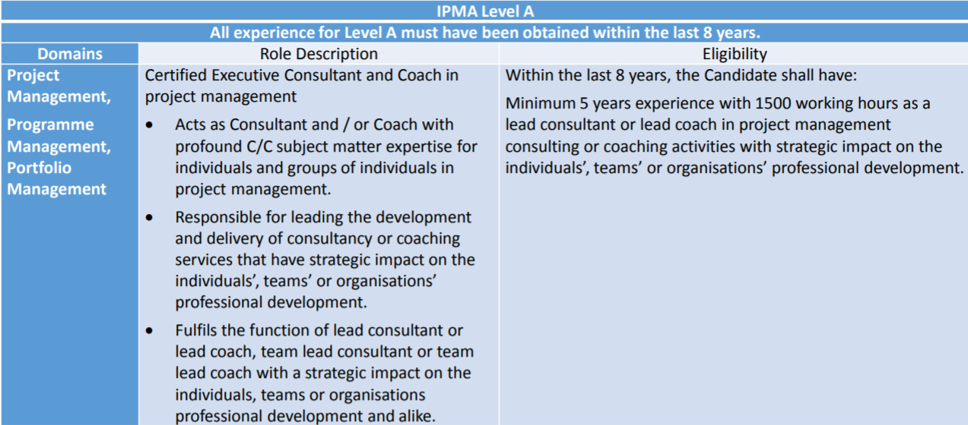
IPMA Level A for T Role Description and Eligibility
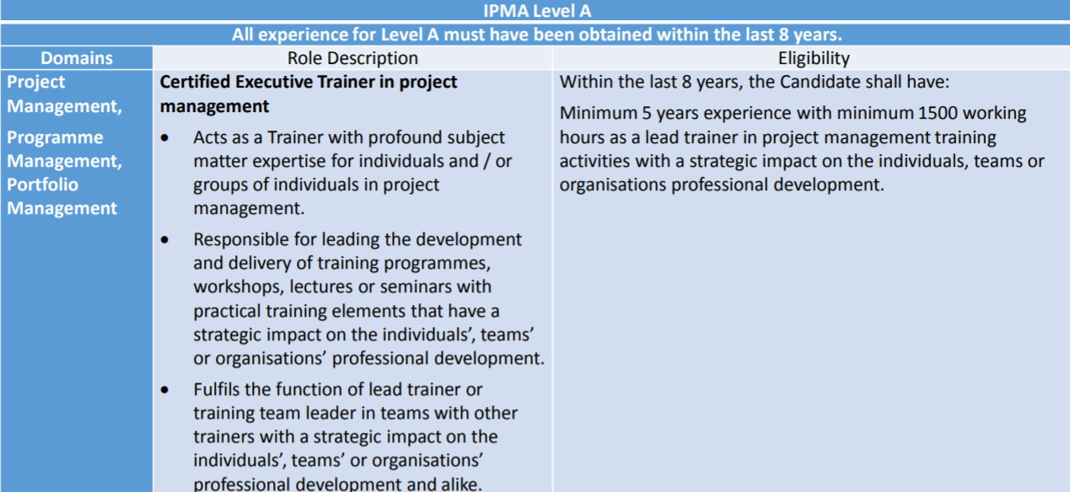

IPMA Level B for CC Role Description and Eligibility
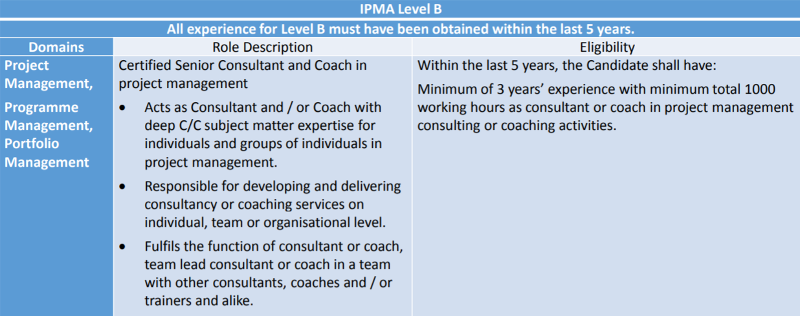

IPMA Level B for T Role Description and Eligibility
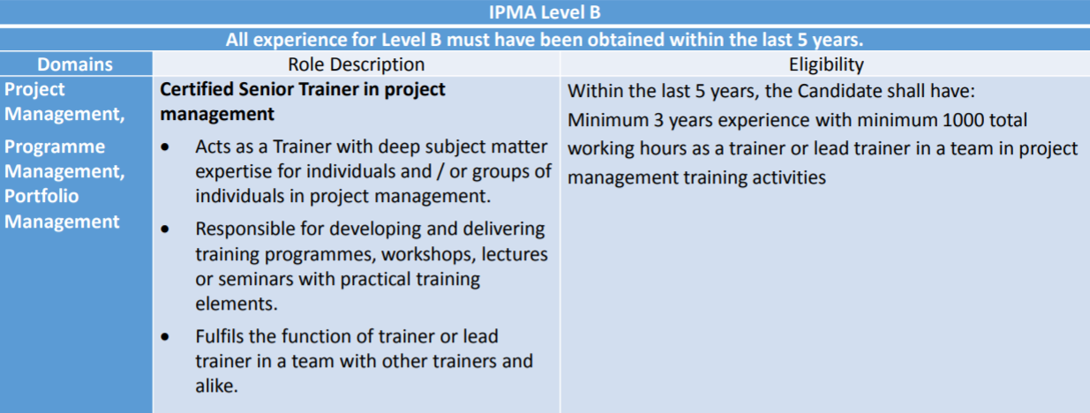

IPMA Level C for CC Role Description and Eligibility
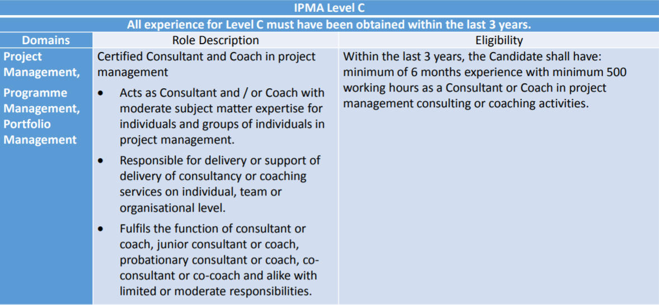

IPMA Level C for T Role Description and Eligibility
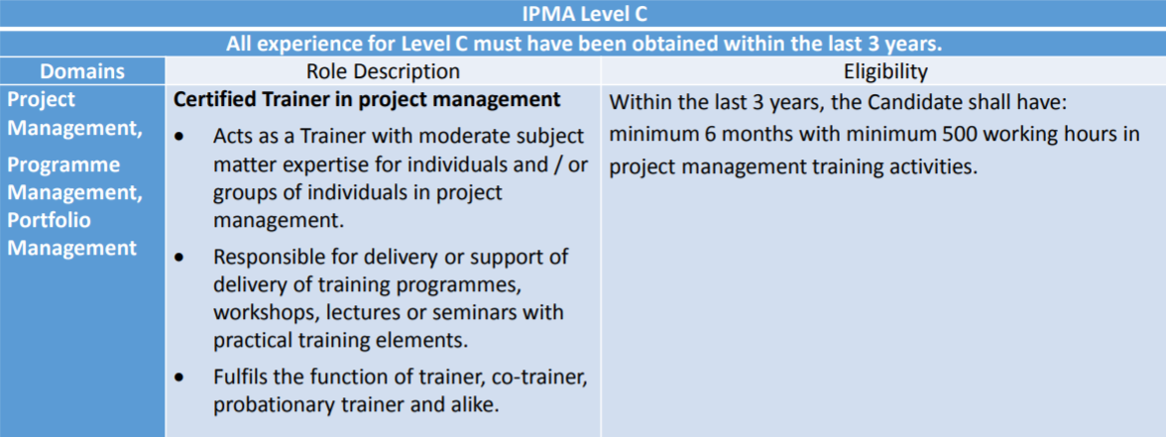
Assessment paths of CCT
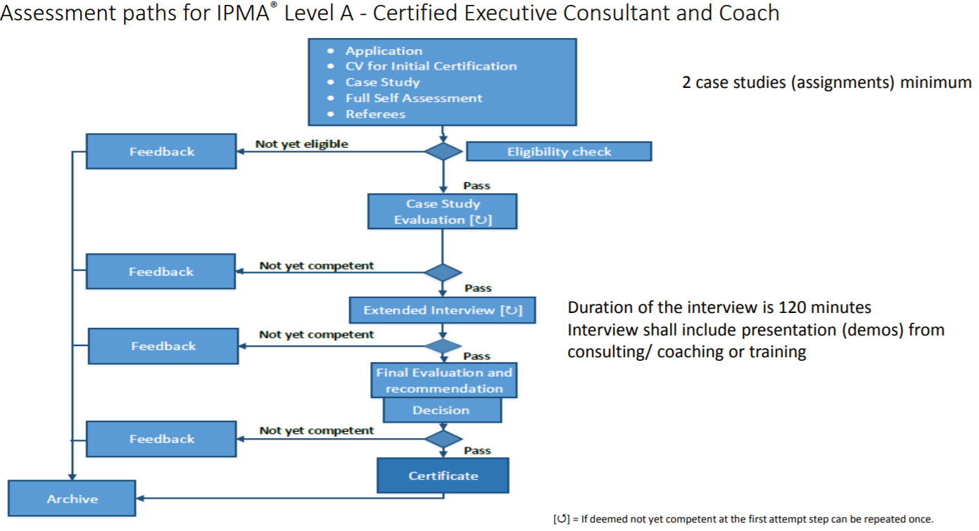

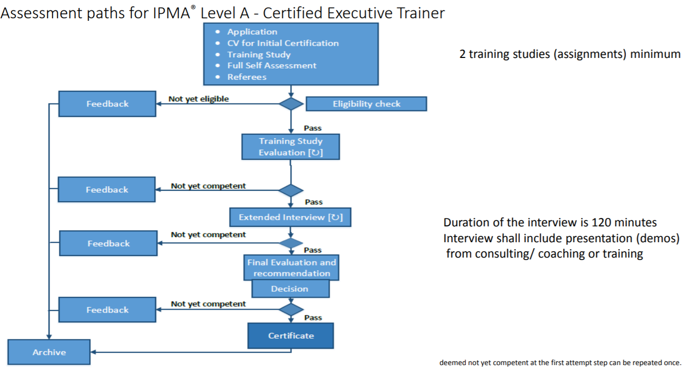

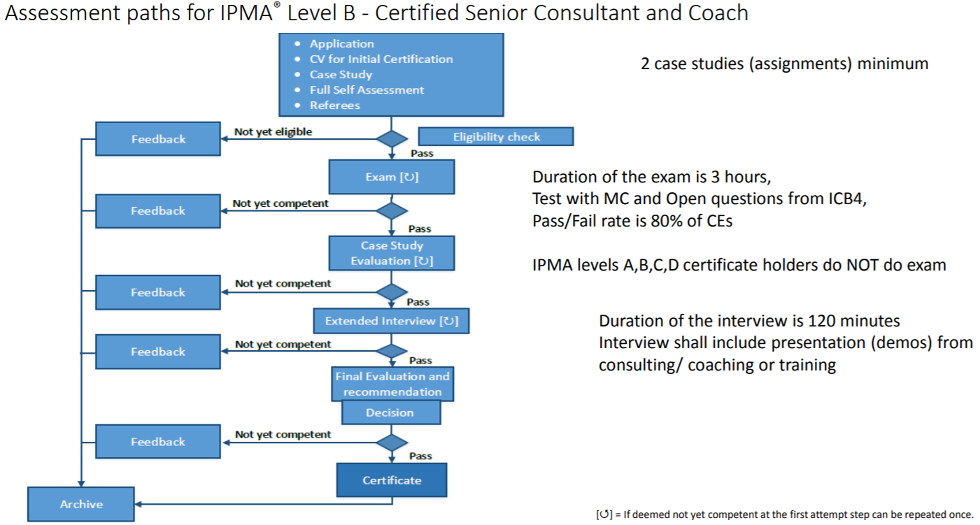

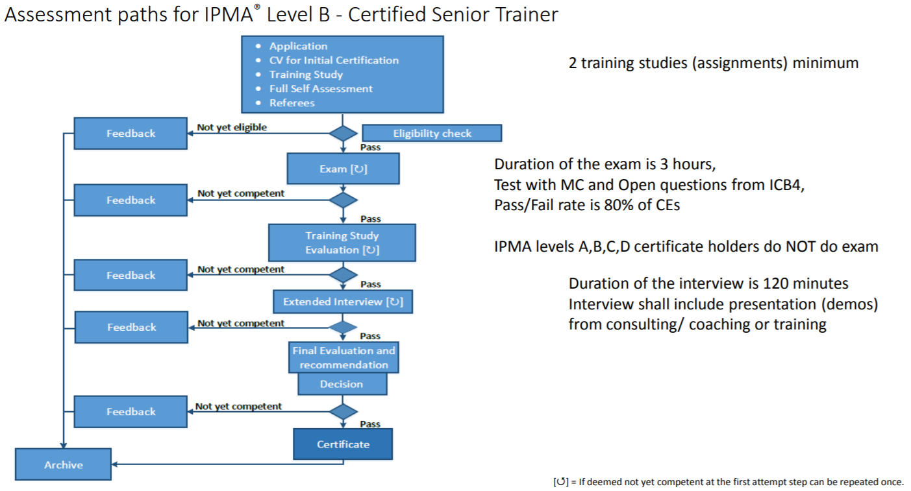
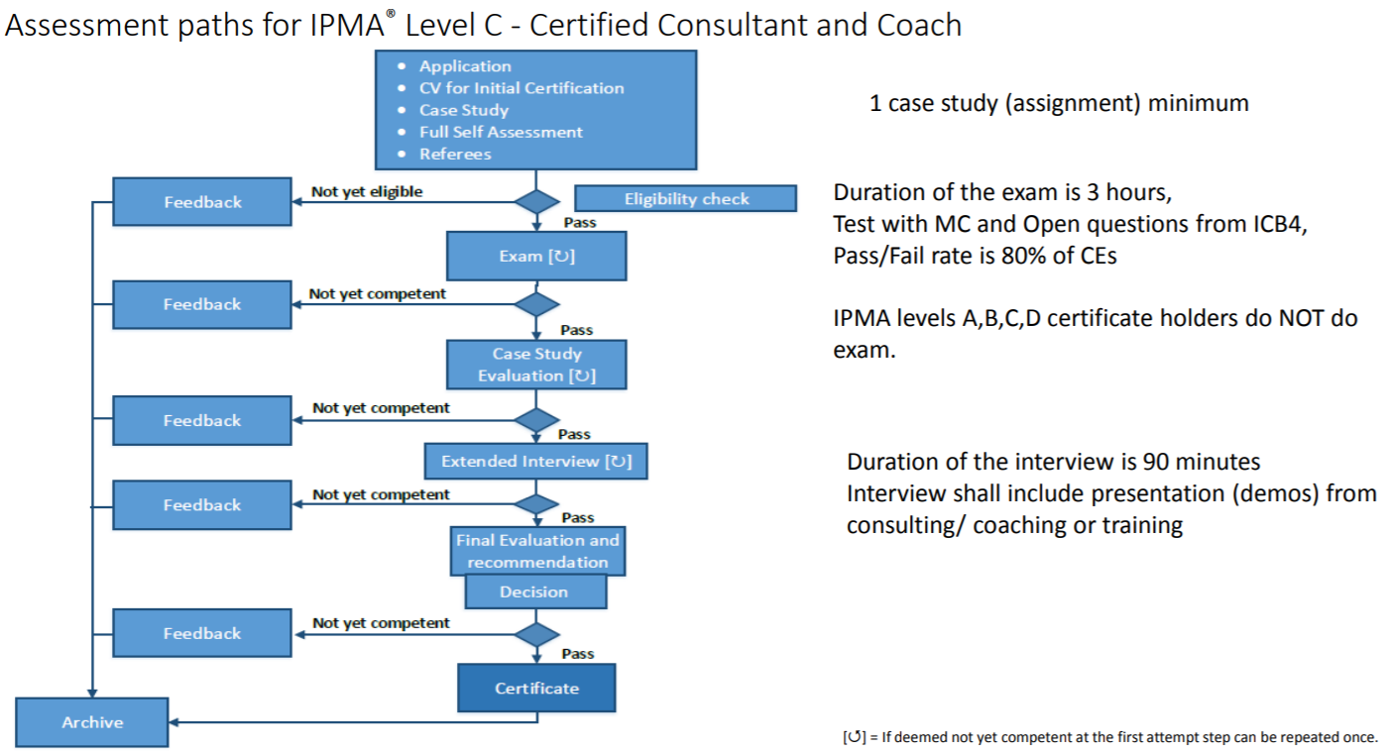

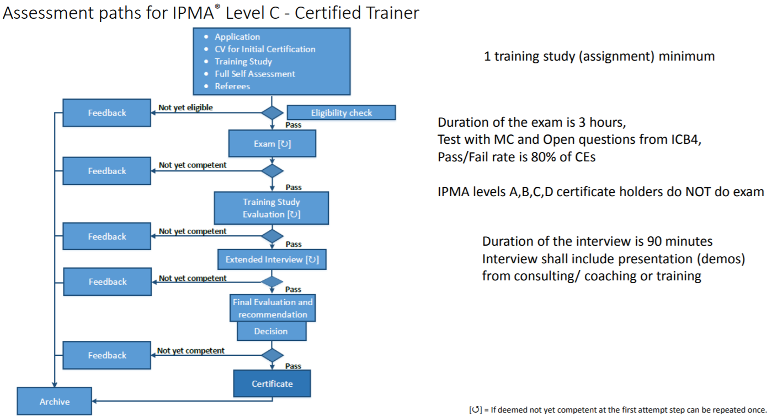

How to apply
Contact our office with your interest to clarify options and to choose the proper assessment path. Prepare by filling in the documents and hand them over to the Certification body (hereinafter CB or SIPR):
• Code of Professional Conduct
• Curriculum Vitae for Initial Certification
• Application (form provided by the CB)
• List of consulting and / or coaching assignments (part of Application form)
• Self – assessment (form provided by the CB)
• Case study for CC and training study for T – describe your assignments that you have conducted (form provided by the CB). Number of case studies (1 or 2) shall differ based on the level of your certification.
• Feedback of training attendees (for T candidates only)
• Referees (part of Application form)

